

**De La Salle University- Manila**

**Gokongwei College of Engineering**

Project Activity Number : 1

Project Activity Title : Type Racer

Date Performed :

Date Submitted :

Instructor : Engr. Leonard U. Ambata

Name of Student : Mayuga, Keenan Eliot L.

Student ID : 11916060

Subject / Section : LBYCPA1 EQ4

Remarks:

_______________________________________________________________

_______________________________________________________________

Instructor’s Signature : ________________

**Problem #1**

A program that tests your typing speed. It will calculate your word per minute and accuracy. We used the pygames library to create a GUI.

**Flowchart:**

(next page)

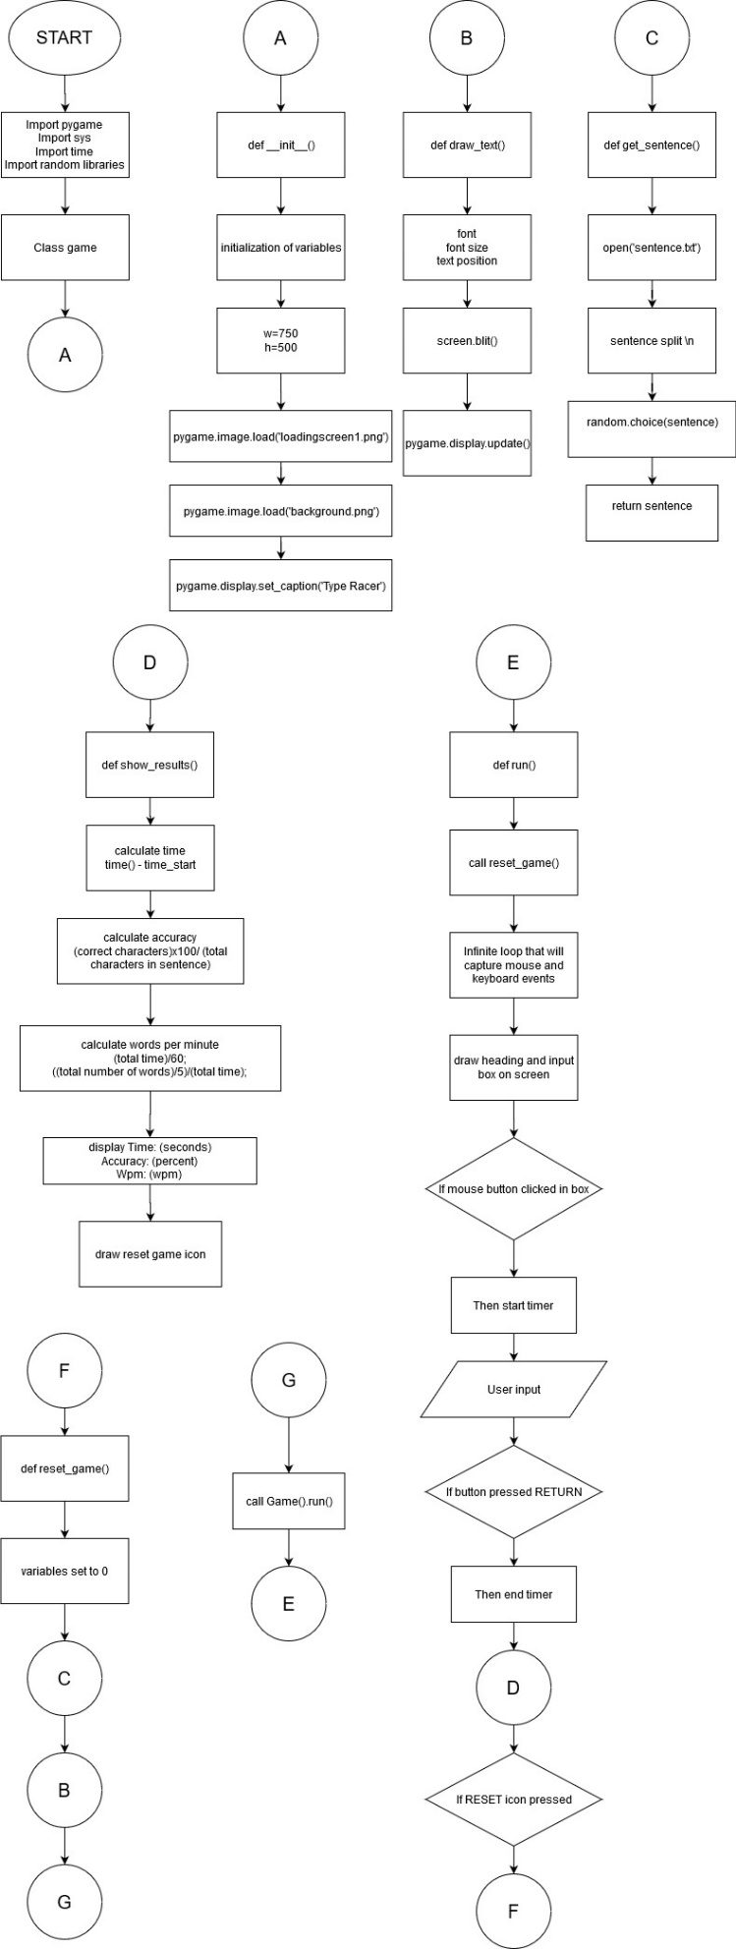

**Python code:**

import pygame

from pygame.locals import *

import sys

import time

import random

class Game:

def __init__(self):

self.w=750

self.h=500

self.reset=True

self.active = False

self.input_text=''

self.word = ''

self.time_start = 0

self.total_time = 0

self.accuracy = '0%'

self.results = 'Time:0 Accuracy:0 % Wpm:0 '

self.wpm = 0

self.end = False

self.HEAD_C = (255,213,102)

self.TEXT_C = (240,240,240)

self.RESULT_C = (255,70,70)

pygame.init()

self.open_img = pygame.image.load('loadingscreen1.png')

self.open_img = pygame.transform.scale(self.open_img, (self.w,self.h))

self.bg = pygame.image.load('background.png')

self.bg = pygame.transform.scale(self.bg, (self.w,self.h))

self.screen = pygame.display.set_mode((self.w,self.h))

pygame.display.set_caption('Type Racer')

def draw_text(self, screen, msg, y ,fsize, color):

font = pygame.font.Font(None, fsize)

text = font.render(msg, 1,color)

text_rect = text.get_rect(center=(self.w/2, y))

screen.blit(text, text_rect)

pygame.display.update()

def get_sentence(self):

f = open('sentences.txt').read()

sentences = f.split('\n')

sentence = random.choice(sentences)

return sentence

def show_results(self, screen):

if(not self.end):

self.total_time = time.time() - self.time_start

count = 0

for i,c in enumerate(self.word):

try:

if self.input_text[i] == c:

count += 1

except:

pass

self.accuracy = count/len(self.word)*100

self.wpm = len(self.input_text)*60/(5*self.total_time)

self.end = True

print(self.total_time)

self.results = 'Time:'+str(round(self.total_time)) +" secs Accuracy:"+ str(round(self.accuracy)) + "%" + ' Wpm: ' + str(round(self.wpm))

self.time_img = pygame.image.load('icon.png')

self.time_img = pygame.transform.scale(self.time_img, (150,150))

screen.blit(self.time_img, (self.w/2-75,self.h-140))

self.draw_text(screen,"Reset", self.h - 70, 26, (100,100,100))

print(self.results)

pygame.display.update()

def run(self):

self.reset_game()

self.running=True

while(self.running):

clock = pygame.time.Clock()

self.screen.fill((0,0,0), (50,250,650,50))

pygame.draw.rect(self.screen,self.HEAD_C, (50,250,650,50), 2)

self.draw_text(self.screen, self.input_text, 274, 26,(250,250,250))

pygame.display.update()

for event in pygame.event.get():

if event.type == QUIT:

self.running = False

sys.exit()

elif event.type == pygame.MOUSEBUTTONUP:

x,y = pygame.mouse.get_pos()

if(x>=50 and x<=650 and y>=250 and y<=300):

self.active = True

self.input_text = ''

self.time_start = time.time()

if(x>=310 and x<=510 and y>=390 and self.end):

self.reset_game()

x,y = pygame.mouse.get_pos()

elif event.type == pygame.KEYDOWN:

if self.active and not self.end:

if event.key == pygame.K_RETURN:

print(self.input_text)

self.show_results(self.screen)

self.draw_text(self.screen, self.results,350, 28, self.RESULT_C)

self.end = True

elif event.key == pygame.K_BACKSPACE:

self.input_text = self.input_text[:-1]

else:

self.input_text += event.unicode

pygame.display.update()

clock.tick(60)

def reset_game(self):

self.screen.blit(self.open_img, (0,0))

pygame.display.update()

time.sleep(1)

self.reset=False

self.end = False

self.input_text=''

self.word = ''

self.time_start = 0

self.total_time = 0

self.wpm = 0

# Get random sentence

self.word = self.get_sentence()

if (not self.word): self.reset_game()

#drawing heading

self.screen.fill((0,0,0))

self.screen.blit(self.bg,(0,0))

msg = "Type Racer"

self.draw_text(self.screen, msg,80, 80,self.HEAD_C)

# draw the rectangle for input box

pygame.draw.rect(self.screen,(255,192,25), (50,250,650,50), 2)

# draw the sentence string

self.draw_text(self.screen, self.word,200, 35,self.TEXT_C)

pygame.display.update()

Game().run()

**Output Screenshots:**



